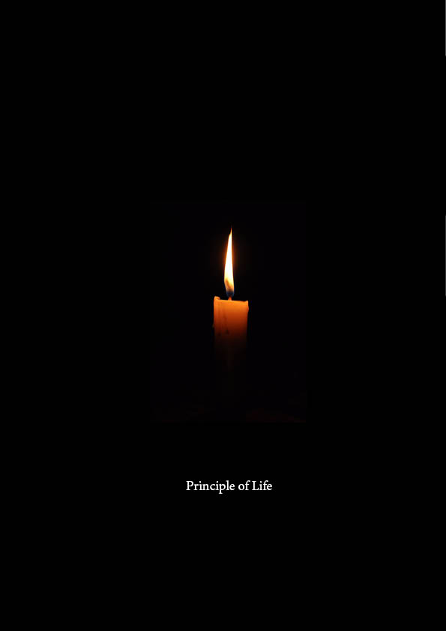
US 19.99

This book explains the purpose of life and all major aspects of life in a scientific, logical, and Lord-guided way without impacting any practice in the current society.

Reading and following this book will give you a clear understanding of Life and its expectations by the lord and also success in every stage and area of life.

This book will help you on a purification service, connect with the lord and prophet’s word book(s), and help you to pass on the judgment day as well as the best life coaching for personal development.

Disclaimer: The book is not the holy book of the lord or prophet collected quotation but only an explanation.

Dedicated to
The most beloved Lord

CONTENTS

PART I: PRINCIPLE

- Philosophy of Life (Before, now, and afterward) and History

- Why Guideline?

PART II: MAJOR PRACTICES

- Major Practices (reason and benefits)

- Major Rewards and Sin (reason and benefits)

PART III: PRACTICES FOR LIFE

- Diet, Health, and Fitness

- Mental Health and addiction

- Relationship and Parenting

- Fashion and Clothing

- Education

- Sociology & social science (behavior, culture, manners)

- Fighting for Lord(meaning)

- Level of believers and their rewards

PART IV: Others

- Politics

- Art, Architecture & Photography

- Motivation Or Inspirational

- Sports and Activities

- Arts and Hobbies

- Self-help

- Travel

- Recreation

- Craft and Hobbies

- Humor

- Music, Film, Performing Arts

- Astrology and Tarot

- Pets

- Women Studies

ACKNOWLEDGMENTS
Lord and his book Quran
Prophet Muhammad(PBUH) and his word from the lord in Hadith

Part I

PRINCIPLE

1
PRINCIPLE OF LIFE

Life…

Here….
God says

CHAPTER 1: Key Points or Notes

End
Asadul Alam, who is a practitioner of the lord's work for the last 40 years and has been a servant for the fourth generation. Currently, he is performing purification services through tours around North America, Europe, and around the globe.

Some of his previous generation's works include the establishment of migration for lord, God’s prayer place, and an education center for women but those were on existing believer groups except one.

Publishers and Distributors
God and Goodness
461 W Woodbury Road
Unit #382 Altadena
California USA 91001

ISBN 978-1-9990706-0-1
Copyright @ God and Goodness Publishers
and Distributors 2023

All rights reserved. No part of this book may be reproduced except for reference, stored in a retrieval system, or transmitted, in any form or by any means, electronic, mechanical, photocopying, recording, or otherwise, without the prior written consent of the publishers.

Print and bound in USA and Canada
Principle of Life
